## **1.****[Balsamiq Mockups](http://balsamiq.com)**

**[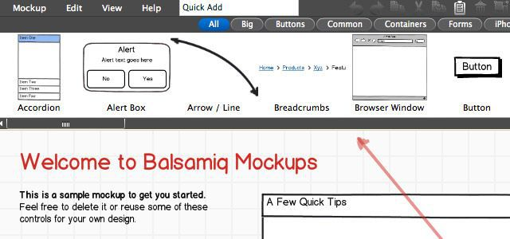](http://balsamiq.com)**

Perhaps one of the more well-known and popular mockup tools, Balsamiq Mockups is a cloud-based mockup service (with accompanying desktop application) that enables you to quickly and easily create fun and interactive website mockups. With its trademark sketchy, hand-drawn look, Balsamiq Mockups lets you focus on solving larger UI problems rather than obsessing over the details.

The application comes with a huge collection of drop-in components and reusable libraries, and an easy drag-and-drop interface. Since it is cross-platform and has full offline support, you can create mockups anywhere.

Pricing for the desktop application starts at $79 for a single-user license, but a 50% discount is available when you sign up for a monthly subscription to myBalsamiq (plans start at $12 per month).

## **2.****[Mockingbird](http://gomockingbird.com)**

**[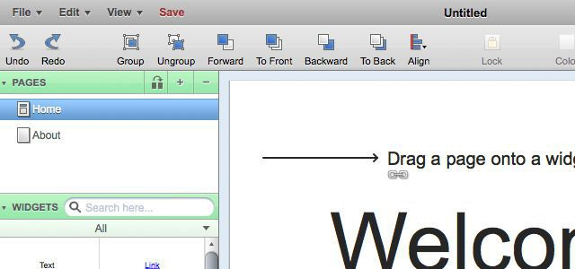](http://gomockingbird.com)**

Mockingbird is another popular web-based wireframing application, with some great functionality baked in for linking and sharing your mockups. Designed for rapid prototyping, Mockingbird lets you create interfaces quickly with the drag-and-drop editor, either alone or in collaboration with a team.

By linking pages together, you can then create interactive mockups and wireframes — perfect for sharing with your clients, reviewing workflow and streamlining your user experience.

Mockingbird subscription plans start at just $9 per month for a personal account (which allows you to have two active projects), and team plans ranging from $20 to $85 per month, depending on the number of projects.

## **3.****[Mockup Builder](http://mockupbuilder.com)**

**[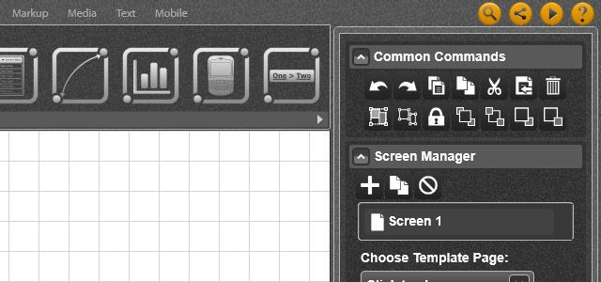](http://mockupbuilder.com)**

Mockup Builder is a free web application built in Microsoft Silverlight that is designed to let you create software and website mockups, then easily share them with clients or coworkers.

The library of available elements is diverse (supporting desktop, browser, iOS and Android components) but limited in quantity. For a free tool, however, Mockup Builder certainly has its bases covered and offers a great starting point for prototyping simple ideas and concepts.

When you're ready to share your mockup, projects can be exported as both PNG and PDF files or shared directly. Those with access can then leave feedback and comments on the project.

## **4.****[MockFlow](http://mockflow.com)**

**[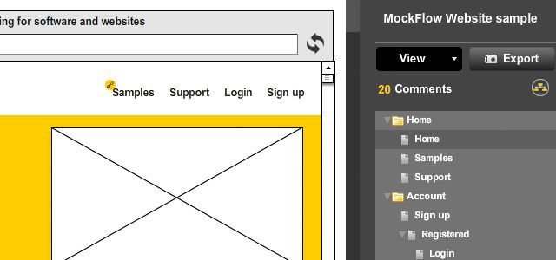](http://mockflow.com)**

MockFlow is a "super-easy wireframing" service that enables you to create and collaborate on complex interactive wireframes and UI prototypes for your web sites and applications.

As with Balsamiq, MockFlow includes a cross-platform desktop application (powered by [Adobe Air](http://adobe.com/air)), so you can build your UI concepts in a streamlined, clutter-free environment with full offline support. MockFlow also includes a free mobile application that is perfect for presenting prototypes to clients and accessing your mockups on the fly. A number of other add-ons are also available.

MockFlow has two pricing options — a free plan that gets you one small project (four pages) with two collaborators, and a Premium package at $99 per year for unlimited projects, several add-ons and a few additional perks. With a price point at under $100 annually for the premium account, Mockflow is one of the more affordable professional solutions.

## **5.****[HotGloo](http://hotgloo.com)**

**[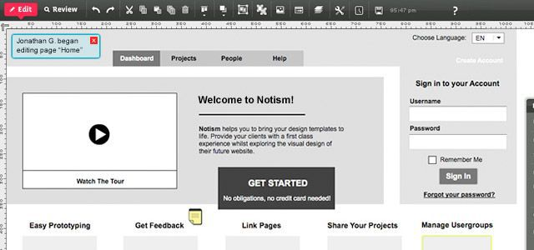](http://hotgloo.com)**

With more than 26,000 projects created, HotGloo is another wireframing and website mockup tool that's been around for quite a while. This web application sports a large library of components, a feature-rich, drag-and-drop interface and tools for both collaboration and review.

The service has one of the more polished web-based authoring environments we've seen, making this application a pleasure to use. With HotGloo, you'll be able to create entire user interactions — you can design, test, revise and review your complete application workflow. Other tools include the ability to create master templates (which can be applied across an entire project), smart element stacks for organizing your UI and role-based access for authors and clients.

HotGloo's pricing plans range from $14 to $54 per month, with a 15-day free trial for new accounts.

## **6.****[Invision](http://invisionapp.com)**

**[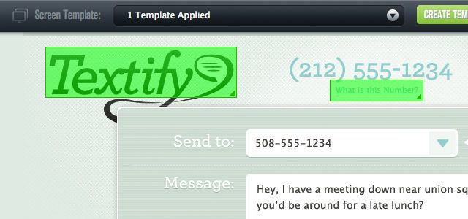](http://invisionapp.com)**

Invision is another online tool aimed at helping you design, share and test your user experience. More than just wireframes, Invision lets you create fully featured and highly interactive mockups with as much polish as you want to put into them. Great collaboration tools make it easy to share projects and work together as a team, and mobile support is quite good.

Whether you're creating high-fidelity prototypes or interactive wireframes, Invision makes authoring and sharing projects easy. The wireframing tools include a large element library, and more detailed mockups give you complete control over images, colors and layout via a streamlined and clean editing environment.

Invision boasts a network of more than 30,000 designers, including some big-name companies. Subscription plans range from free (for up to two projects) to $75 per month for up to 20 active projects. There's also a 30-day free trial on all accounts.

## **7.****[JustProto](http://justproto.com)**

**[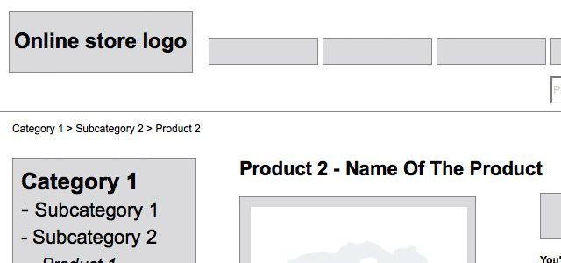](http://justproto.com)**

JustProto is a wireframing web application with a few features we haven't seen in other products. Like many similar offerings, JustProto has a large library of wireframe elements and widgets, accessible via a simple drag-and-drop interface. However, there are a few other key features that set JustProto apart from the crowd.

Not only can you share projects via a single share link, JustProto also enables you to collaborate in real-time with other designers, chat with clients and collaborators, and keep a history of all chat communication. With JustProto, you can create fully featured, interactive wireframes in real-time and then gather instant feedback.

JustProto plans range from $19 to $99 per month, with custom packages available for large-scale and enterprise customers. A free 15-day trial period is provided, and there's no credit card required to sign-up.

## **8.****[Proto.io](http://proto.io)**

**[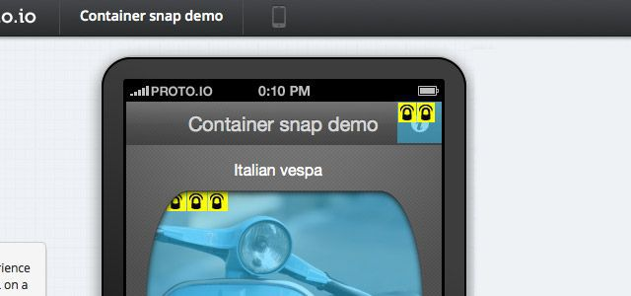](http://proto.io)**

Proto.io is an application prototyping platform designed specifically for prototyping mobile applications. This web app helps you to create mobile mockups with ease for [iPhone](http://mashable.com/category/iphone/), [iPad](http://mashable.com/category/ipad/), [Android](http://mashable.com/category/android/) and a number of other devices. Proto.io gives you full control over colors, fonts and layout, and it comes with a large element library to make building rich prototypes easier.

Proto.io also lets you share projects and collaborate with other designers. Proto.io mockups can be viewed directly on your mobile device, giving you a better feel for how your application will look and function in a real-world setting, or you can view projects via the Proto.io web player.

There's a free plan available, which is good for one small (five screen) project, and paid subscriptions are $24 and $49 per month, with fairly generous offerings on disk quota, screens, collaborators and other resources.

## **9.****[inPresso Screens](http://www.inpreso.com/)**

**[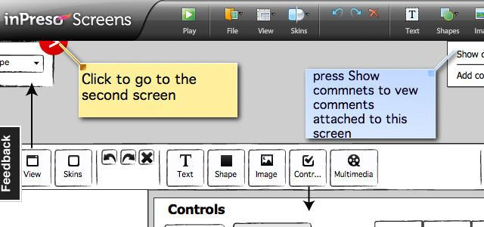](http://www.inpreso.com/)**

Last, but not least, inPresso Screens is a prototyping tool for both desktop software and websites. One of the things we like about inPresso is the ability to skin applications using popular window manager themes from a variety of operating systems. This is great if you're mocking up a desktop application and you need to get a real feel for what the final product will look like.

inPresso is available as a free desktop application or via subscription, with some pretty important distinctions between the two. The free version gives you a desktop tool for authoring application prototypes and wireframes which can be saved and edited locally. In addition to the base tools, the subscription package also allows access to an online library of UI elements, and enables instant online publication and sharing of your prototypes as well as a web player for presenting prototypes to your clients.

The desktop application itself is cross-platform and annual subscriptions are only $29 per year.